**Introduction**

**MADP** (Mobile Application Development Platform) Viewer is a unique application development and designing platform which makes application designing easy and fast. It works upon well defined and tested codes and with making new XML files and changing

So here I am going to explain that how XML files work and how does it affect our android and iPhone applications.

**How Does XML Works:**

Using XML we have divided a single screen in three sections:

1. Top View
2. Middle View
3. Bottom View

Color, height, width, background color, spacing and all other things are controllable the only fixed thing is their position means the top bar will always come at the top only. Middle will come after the top bar and bottom will come after the middle section.

**Screen:**

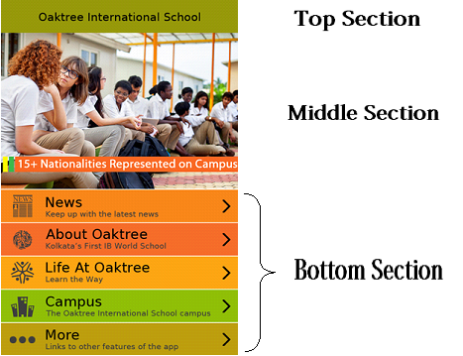

|  |
| --- |
| Sample XML Code of a Screen : |

<Screen Number="110" Type="" bgcolor="" bgImage="" Link= “”>

***<Top*** rows="" columns="" width="100" height="10" Type="0" Link="" bgcolor="#93950A" bgImage=""> </Top>

<***Middle*** rows="" columns="" width="100" height="90" Type="6" Link="" bgcolor="" bgImage=""> </Middle>

<***Bottom*** rows="1" columns="3" width="100" height="10" Type="" Link="" bgcolor="" bgImage="">

</Bottom></Screen>

|  |  |
| --- | --- |
| Screen XML Details : | |
| **Attributes** | **Work** |
| Screen Number | This is different for every screen and this is like name of every screen which differentiates screens. |
| bgcolor | This gives a background color to app screen.  Ex: "#FFFFFF" |
| bgImage | This gives a background image to app screen. Ex: “name of the image” |

|  |  |
| --- | --- |
| Top section XML Details : | |
| **Attributes** | **Work** |
| width | This field is width of the Top section means what % of the total screen width we want to use as a top bar width. |
| height | This field is height of the Top section means what % of the total screen height we want to use as a top section. |
| Type | What kind of top view we want to see.  Ex: 1 for grid view, 2 for list view, for more see the Type list. |
| bgImage | This gives a background image to the top part of the app. |
| bgcolor | This gives a background color to the top part of the app. |
| Link | If we want to open a web link in web browser. Then we will use this field. But if we are using some list or grid view then the only possible thing is the link will open in inapp browser. |
| verticalSpacing | Gives the spacing in grid |
| horizontalSpacing | This is for the horizontal spacing in grid |

|  |  |
| --- | --- |
| Middle section XML Details : | |
| **Attributes** | **Work** |
| width | This field is width of the middle section means what % of the total screen width we want to use as a Middle section width. |
| height | This field is height of the Top bar means what % of the total screen height we want to use as a Middle section. |
| Type | What kind of top view we want to see.  Ex: 1 for grid view, 2 for list view, for more see the Type list. |
| bgImage | This gives a background image to the top part of the app. |
| bgcolor | This gives a background color to the top part of the app. |
| Link | If we want to open a web link in web browser. Then we will use this field. But if we are using some list or grid view then the only possible thing is the link will open in inapp browser. |
| verticalSpacing | Gives the spacing in grid |
| horizontalSpacing | This is for the horizontal spacing in grid |

|  |  |
| --- | --- |
| Bottom section XML Details : | |
| **Attributes** | **Work** |
| width | This field is width of the middle section means what % of the total screen width we want to use as a Bottom section width. |
| height | This field is height of the Top bar means what % of the total screen height we want to use as a Bottom section. |
| Type | What kind of top view we want to see.  Ex: 1 for grid view, 2 for list view, for more see the Type list. |
| bgImage | This gives a background image to the top part of the app. |
| bgcolor | This gives a background color to the top part of the app. |
| Link | If we want to open a web link in web browser. Then we will use this field. But if we are using some list or grid view then the only possible thing is the link will open in inapp browser. |
| verticalSpacing | Gives the spacing in grid |
| horizontalSpacing | This is for the horizontal spacing in grid |

|  |
| --- |
| Screen Number : |
| Screen Number=-2 is for Agreement Screen  Screen Number=-1 is for Splash  Screen Number=0 is for HomePage  Screen Number=1 is for Mail  Screen Number=2 is for Google Map  Screen Number=3 is for Tweeter  Screen Number=4 is for FaceBook  Screen Number=5 is for save the image  Screen Number=50 is for MenuPage  Screen Number=10 is for Show Update Detail page  Screen Number=102 is for Show Update  Screen Number=100 is for Picture Gallery  Screen Number=11 is for Picture Gallery GridView  Screen Number=112 is for Picture Gallery Detail View  Screen Number=114 is for Open original Image of an HTML page.  Screen Number=115 is for Video Gallery List Page  Screen Number=116 is for Video Display Page  Screen Number=110 is for Exhibitor Directory Page  Screen Number=117 is for Hall Page  Screen Number=118 is for Section Page  Screen Number=119 is for All Exhibitor Page  Screen Number=120 is for Exhibitor Detail Page  Screen Number=108 is for Event Schedule Page  Screen Number=121 is for Event Schedule Detail Page  Screen Number=125 is for Tab buttons |

**Element Details:**

For making a screen more useful we can further divide the top middle and bottom section in their element and in every part any numbers of elements are possible.

**Example of Splash Screen:**

|  |
| --- |
| XML Code of a Splash Screen : (Working) |
| <?xml version="1.0" encoding="UTF-8"?>  **<Screens>**  <!-- Splash Screen -->  **<Screen** Number="-1" Type="" bgcolor="#FFFFFF" bgImage="">  **<Top** rows="" columns="" width="100" height="100" Type="8" Link="" bgcolor="" bgImage="">  ***<Element*** maxline="" Subtitle="" font="Rupee Foradian Standard,14,#1570b8" leftscalefactor="" rightscalefactor=""  midscalefactor="" selectedBgcolor="" bgcolor="” txtColor="" Number="" Code="" Type=”" Title="" Bitmap="Splash_JJS" OnClick="" width="100" height="100" left="" right="" bottom="" leftper="" rightper="" middleper="" distleft="" disttop="" mailto="" body="" subject="" leftClick="" rightClick="" rightbgColor="" leftbgColor="" midbgColor="" rightbgImage="" leftbgImage="" midbgImage="" />  **</Top>**  **<Middle** rows="" columns="" width="1" height="0" Type="" Link="" bgcolor="" bgImage="">  **</Middle>**    **<Bottom** rows="" columns="" width="100" height="0" Type="8" Link="" bgcolor="" bgImage="">  **</Bottom>**  **</Screen>**  **</Screens>** |

Splash Screen can contain any data. And that data can be any of the available type.

|  |  |
| --- | --- |
| Element XML Details : | |
| **Attributes** | **Work** |
| bgcolor | Background color of the element |
| bitmap | Image which we want to use for the element |
| body |  |
| code | The code of the HTML page which we want to open |
| distleft |  |
| Disttop |  |
| Font | Font name and font size of the title of the element. |
| Height |  |
| Left |  |
| leftbgColor | If we want to give a different background color to the left part of the element. |
| leftbgImage | If we want to give a different background image to the left part of the element. |
| leftClick | Name or number of the screen which will open on clicking upon the left icon of the element. |
| Leftper |  |
| leftscalefactor |  |
| mailto |  |
| maxline |  |
| midbgColor | If we want to give a different background color to the middle part of the element. |
| midbgImage | If we want to give a different background image to the middle part of the element. |
| middleper |  |
| midscalefactor |  |
| number |  |
| onClick | Name or number of the screen which will open on clicking upon the element. |
| Right |  |
| rightbgColor |  |
| rightbgImage |  |
| rightClick |  |
| rightper |  |
| rightscalefactor |  |
| selectedBgcolor | The color of the element when we click the element. |
| Subject |  |
| Subtitle | If we want to give some subtitle to an element. We use this in a list view. |
| Title | Title of the element |
| txtColor | The color of our title of the element. |
| Type |  |
| Width | This is the % width of the element considering the total % of that particular section. |
| TitleGravity | For selecting the starting position of title . |
| SubTitleGravity | For selecting the starting position of the subtitle. |
| SubTitleFont | For setting the font type, size and color of the content. |
| Link | We will use this for opening anything in external browser in case of list and grid. |
| shareText | In this case we will write the text whatever we want to share on clicking upon share button in a HTML page. |
| imageHeight | This will decide the height of the image |
| imageWidth | This will decide the width of the image |
| textHeight | This will decide the height of the text which comes after image in grid |
| textWidth | This will decide the width of the text which comes after image in grid |
| dividerColor | This will give a color to the divider of the list means in the above image the color is white. |
| Datefont | Font and the color of the date |
| Timefont | Font and the color of the time |
| TopMargin | For the top margin between the elements of the grid |
| TextMode | We want text at the top or at the bottom |
| TextTransColor | The background color of text in transparent form |
| ImageMode | Crop / Scale . by default is scale. |
| ImageSet | For selecting images for flick |
| ReadNewsfont | Color of the read news. |
| Datebg | Background color of the date |
| circleColor | If we want to change the color of the circle of manual flick. |
| Imageurlset | For setting multiple URL in flick |

|  |
| --- |
| Types : (Fixed Not changeable) |
| Section Type=-1 for Splash Screen  Section Type="0" for Top View  Section Type="1" for Grid View  Section Type="2" for List View  Section Type="2.1" for List View with subtitle  Section Type="3" for Html View with Link  Section Type="4" for Advertisement Bar View  Section Type="20" for Flick images automatically.  Section Type="20.1" for Flick images manually.  Section Type="20.2" for Flick images Automatically with fixed images.  Section Type="20.3" for Flick images manually with fixed images.  Section Type="6" for Html page without link  Section Type="12" for Category View  Section Type="13" for Picture Grid View  Section Type="8" for Picture Detail View  Section Type="42" for Text Field.  Section Type="43" for Placing button at X and Y location.  Section Type="10" for News  Section Type="11" for News Details  Section Type="24" for category |

|  |
| --- |
| Codes (Example): |
| P101 – All Exhibitors  P102 – Exhibitor Type  P103 – Hall Types  P104 - Sections |

**List View:**

List View is Type 2. Type 2.1 is for list view with subtitles. We can use list as top or middle or bottom section In this we need to use only.

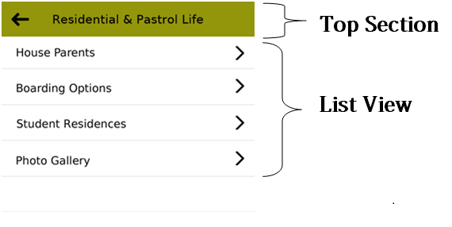

|  |
| --- |
| XML Code of a List View : (Working) |
| <Screen Number="101" Type="" bgcolor="#ffffff" bgImage="">    <Top rows="" columns="" width="100" height="10" Type="0" Link="" bgcolor="#f7a721" bgImage="">  <Element maxline="" Subtitle="" font="Rupee Foradian Standard,30,#000000" leftscalefactor="" rightscalefactor="" midscalefactor="" selectedBgcolor="" bgcolor="#E6E616" txtColor="" Number="0" Code="" Type="0" Title="About Us" Bitmap="" OnClick="” width="100" leftper="20" rightper="" middleper="" height="100" left="back_icon" right="" middle="" leftClick="Open_Screen 0" rightClick="" body="" mailto="" subject="" distleft="" disttop="" rightbgColor="" leftbgColor="" midbgColor="" rightbgImage="" leftbgImage="" midbgImage="" />  </Top>  **<Middle rows="" columns="" width="100" height="90" Type="2" Link="" bgcolor="#ffffff" bgImage="">**  **<Element maxline="" Subtitle="" font="Rupee Foradian Standard,28,#000000" leftscalefactor=""rightscalefactor="" midscalefactor=""selectedBgcolor="#f06b2a" leftper="0" rightper="" middleper="100" bgcolor="" txtColor="" Number="1" Code="" Type="" Title="Directors Note" Bitmap="" OnClick="Open_Screen 102" width="100" height="10" left="" right="" distleft="" disttop="" mailto="" body="" subject="" leftClick=""rightClick="" rightbgColor="" leftbgColor="" midbgColor="" rightbgImage="" leftbgImage="" midbgImage="" />**    </Middle>    <Bottom rows="" columns="” width="100" height="0" Type="0" Link="" bgcolor="" bgImage=""  </Bottom>    </Screen> |

|  |  |
| --- | --- |
| List View XML Details : | |
| **Attributes** | **Work** |
| font | The font used for title and sub titles |
| height | Height in % of the total height of that section |
| left | Name of the image we want to use in the left section of the list element. |
| leftbgcolor | Background color of the left part of the list element. |
| leftclick | Which screen we want to open on clicking upon the left part. |
| leftper | % of the left part of total width |
| midbgcolor | Background color of the middle part of the list element. |
| middleper | % of the middle text part of total width of the list . (in middle part we can use text only) |
| number | The sequencing number in which want to see the list elements. |
| right | Name of the image we want to use in the right section of the list element. |
| rightbgcolor | Background color of the right part of the list element. |
| rightclick | Which screen we want to open on clicking upon the right part.. |
| rightper | % of the Right part of total width |
| selectbgcolor | The new color which will appear when we click and list element. |
| subtitle (only in the case of 2.1) | This will work in the case of 2.1 only and this gives subtitle to the middle element of the list. |
| width | Width of a single element in a list |
| onClick | Which screen we want to open on clicking upon the list. And at time only left / right or onclick will work. |
| dividerColor | This will give a color to the divider of the list means in the above image the color is white. |

**List View with subtitles:**

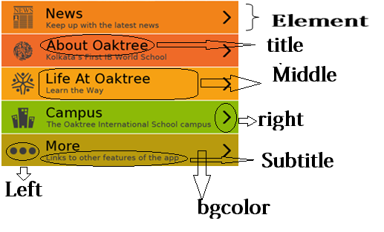

|  |
| --- |
| XML Code of a List View with subtitles : (Working) |
| <Screen Number="101" Type="" bgcolor="#ffffff" bgImage="">    <Top rows="" columns="" width="100" height="10" Type="0" Link="" bgcolor="#f7a721" bgImage="">  <Element maxline="" Subtitle="" font="Rupee Foradian Standard,30,#000000" leftscalefactor="" rightscalefactor="" midscalefactor="" selectedBgcolor="" bgcolor="#E6E616" txtColor="" Number="0" Code="" Type="0" Title="About Us" Bitmap="" OnClick="” width="100" leftper="20" rightper="" middleper="" height="100" left="back_icon" right="" middle="" leftClick="Open_Screen 0" rightClick="" body="" mailto="" subject="" distleft="" disttop="" rightbgColor="" leftbgColor="" midbgColor="" rightbgImage="" leftbgImage="" midbgImage="" /></Top>  **<Middle rows="" columns="" width="100" height="90" Type="2.1" Link="" bgcolor="#ffffff" bgImage="">**  **<Element maxline="" Subtitle="Learn the way" font="Rupee Foradian Standard,28,#000000" leftscalefactor=""rightscalefactor="" midscalefactor=""selectedBgcolor="#f06b2a" leftper="0" rightper="" middleper="100" bgcolor="" txtColor="" Number="1" Code="" Type="" Title="Directors Note" Bitmap="" OnClick="Open_Screen 102" width="100" height="10" left="" right="" distleft="" disttop="" mailto="" body="" subject="" leftClick=""rightClick="" rightbgColor="" leftbgColor="" midbgColor="" rightbgImage="" leftbgImage="" midbgImage="" />**    **</Middle>**  <Bottom rows="" columns="” width="100" height="0" Type="0" Link="" bgcolor="" bgImage=""  </Bottom>    </Screen> |

|  |  |
| --- | --- |
| List View XML Details : | |
| **Attributes** | **Work** |
| subtitle (only in the case of 2.1) | This will work in the case of 2.1 only and this gives subtitle to the middle element of the list. |

**Grid View:**

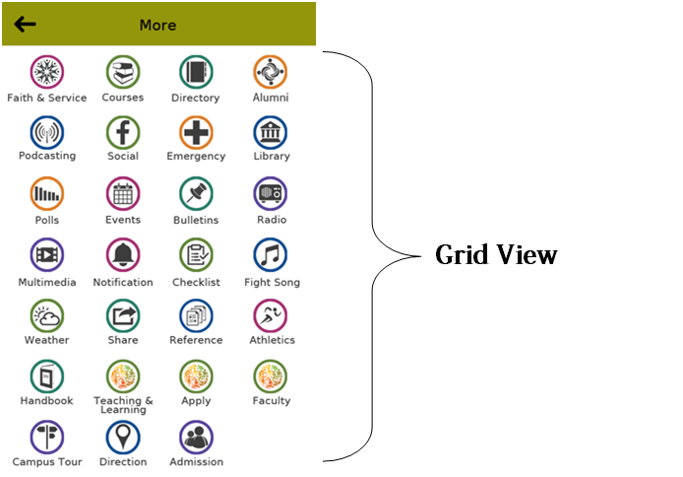

|  |
| --- |
| XML Code of a Grid View : (Working) |
| <Screen Number="101" Type="" bgcolor="" bgImage="">  **<Top rows="" columns="" width="100" height="100" Type="1" Link="" >**  **<Element maxline="" Subtitle="" font="Rupee Foradian Standard,30,#000000" leftscalefactor="" rightscalefactor="" midscalefactor="" selectedBgcolor="" leftper="" rightper="" middleper="" bgcolor="" txtColor="" Number="1" Code="" Type="" Title="About Us" Bitmap="About-Us" OnClick="Open_Screen 101" width="10" height="10" left="" right="" distleft="" disttop="" mailto="" body="" subject=""leftClick="" rightClick="" rightbgColor="" leftbgColor="" midbgColor="" rightbgImage="" leftbgImage="" midbgImage="" />**  **</Top>**  <Middle rows="" columns="" width="" height="0" Type="" Link="" bgcolor="" bgImage="">  </Middle>  <Bottom rows="" columns="" width="" height="" Type="" Link="" >  </Bottom>  </Screen> |

|  |  |
| --- | --- |
| Grid View XML Details : | |
| **Attributes** | **Work** |
| font | The font used for title |
| height | Height in % of the total height of that section |
| number | The sequencing number in which want to see the grid elements. |
| onClick | Which screen we want to open on clicking upon the list. |
| Bitmap | Image which we want to use for the element |
| width | Width of a single element in grid. |
| imageHeight | This will decide the height of the image |
| imageWidth | This will decide the width of the image |
| textHeight | This will decide the height of the text which comes after image in grid |
| textWidth | This will decide the width of the text which comes after image in grid |
| verticalSpacing | Gives the spacing in grid |
| horizontalSpacing | This is for the horizontal spacing in grid |
| TopMargin | For the top margin between the elements of the grid |
| TextMode | We want text at the top or at the bottom |
| TextTransColor | The background color of text in transparent form |
| ImageMode | Crop / Scale . by default is scale. |

**HTML page:**

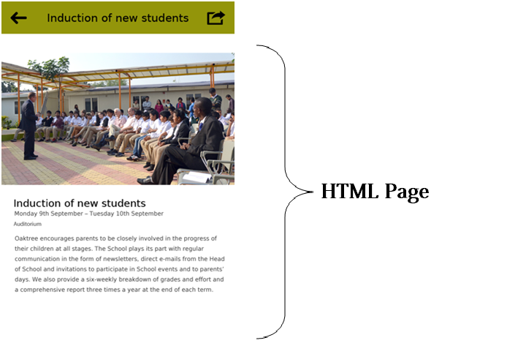

|  |
| --- |
| XML Code of opening a HTML page: (Working) |
| <Screen Number="102" Type="" bgcolor="#ffffff" bgImage="">  <Top rows="" columns="" width="100" height="10" Type="0" Link="" bgcolor="#f7a721" bgImage="" Code="">  <Element maxline="" Subtitle="" font="Rupee Foradian Standard,30,#000000" leftscalefactor="" rightscalefactor="" midscalefactor="" selectedBgcolor="" bgcolor="" txtColor="" Number="0" Code="" Type="" Title="Directors Note" Bitmap="" OnClick="" width="100" leftper="15" rightper="15" middleper="80" height="100" left="back_icon" right="" middle="" leftClick="Open_Screen 0" rightClick="" body="" mailto="" subject="" distleft="" disttop="" rightbgColor="" leftbgColor="" midbgColor="" rightbgImage="" leftbgImage="" midbgImage="" />  </Top>  **<Middle rows="" columns="" width="100" height="90" Type="6" Link="" bgcolor="#ffffff" bgImage="">**  **<Element maxline="" Subtitle="" font="" leftscalefactor="" rightscalefactor="" midscalefactor=""selectedBgcolor="" leftper="" rightper="" middleper="" bgcolor="" txtColor="" Number="" Code="P010" Type="" Title="" Bitmap="" OnClick="" width="100" height="100" left="" right="" distleft="" disttop="" mailto="" body="" subject="" leftClick="" rightClick="" rightbgColor="" leftbgColor="" midbgColor="" rightbgImage="" leftbgImage="" midbgImage="" />**  **</Middle>**  <Bottom rows="" columns="" width="" height="0" Type="" Link="" bgcolor="" bgImage="">  </Bottom>  </Screen> |

|  |  |
| --- | --- |
| HTML Page XML Details : | |
| **Attributes** | **Work** |
| height | Height in % of the total height of that section |
| width | Width of total section. |
| Code | The code is the unique number assigned to a HTML page which we want to open. |
| shareVisiblity | If we want to show the visibility option |
| textChangeSizeVisiblity | If we want to show the Text change size option |

**HTML page with link:**

|  |
| --- |
| XML Code of opening a HTML page with link : (Working) |
| <Screen Number="102" Type="" bgcolor="#ffffff" bgImage="">  <Top rows="" columns="" width="100" height="10" Type="0" Link="" bgcolor="#f7a721" bgImage="" Code="">  <Element maxline="" Subtitle="" font="Rupee Foradian Standard,30,#000000" leftscalefactor="" rightscalefactor="" midscalefactor="" selectedBgcolor="" bgcolor="" txtColor="" Number="0" Code="" Type="" Title="Directors Note" Bitmap="" OnClick="" width="100" leftper="15" rightper="15" middleper="80" height="100" left="back_icon" right="" middle="" leftClick="Open_Screen 0" rightClick="" body="" mailto="" subject="" distleft="" disttop="" rightbgColor="" leftbgColor="" midbgColor="" rightbgImage="" leftbgImage="" midbgImage="" />  </Top>  **<Middle rows="" columns="" width="100" height="90" Type="3" Link=**[**http://jaipurliteraturefestival.org/media/press-release/**](http://jaipurliteraturefestival.org/media/press-release/) **bgcolor="#ffffff" bgImage="">**  **<Element maxline="" Subtitle="" font="" leftscalefactor="" rightscalefactor="" midscalefactor=""selectedBgcolor="" leftper="" rightper="" middleper="" bgcolor="" txtColor="" Number="" Code="" Type="" Title="" Bitmap="" OnClick="" width="100" height="100" left="" right="" distleft="" disttop="" mailto="" body="" subject="" leftClick="" rightClick="" rightbgColor="" leftbgColor="" midbgColor="" rightbgImage="" leftbgImage="" midbgImage="" />**  **</Middle>**  <Bottom rows="" columns="" width="" height="0" Type="" Link="" bgcolor="" bgImage="">  </Bottom>  </Screen> |

|  |  |
| --- | --- |
| HTML Page with Link XML Details : | |
| **Attributes** | **Work** |
| height | Height in % of the total height of that section |
| width | Width of total section. |
| Link | The link is the online web address which we want to open in our in app browser. |

**Advertisement bar view:**

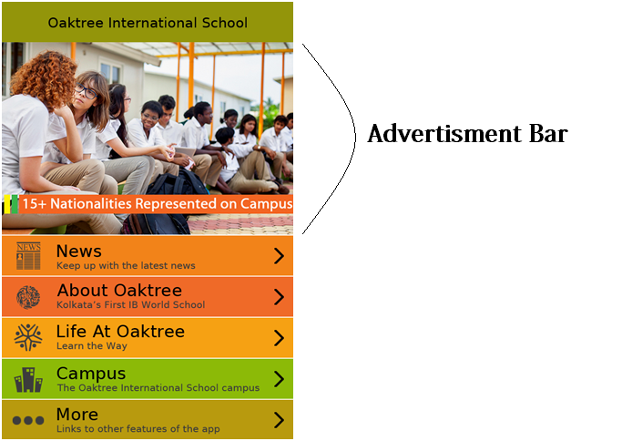

|  |
| --- |
| XML Code of Advertisement bar view : (Working) |
| <Screen Number="0" Type="" bgcolor="" bgImage="">  <Top rows="" columns="" width="100" height="10" Type="0" Link="" bgcolor="#93950A" bgImage="">  <Element maxline="" Subtitle="" font="Rupee Foradian Standard,30,#000000" leftscalefactor="" rightscalefactor="" midscalefactor="" selectedBgcolor=" " bgcolor="#f38a25" txtColor="" Number="" Code="" Type="" Title="Oaktree International School" Bitmap="" OnClick="" width="100" leftper="15" rightper="15" middleper="70" height="100" left="back_icon" right="" middle="" leftClick="" rightClick="" body="" mailto="" subject="" distleft="" disttop="" rightbgColor="" leftbgColor="" midbgColor="" rightbgImage="" leftbgImage="" midbgImage="apply" />  </Top>  **<Middle rows="" columns="" width="100" height="40" Type="4" Link="http://www.oaktree.ac.in/" bgcolor="#ffffff" bgImage="">**  **<Element maxline="" Subtitle="" font=" " leftscalefactor="" rightscalefactor="" midscalefactor="" selectedBgcolor="#f7a721" leftper="0" rightper="5" middleper="95" bgcolor=" " txtColor="" Number="" Code=" " Type="" Title="Faculty" Bitmap="banner" OnClick="" width="100" height="100" left="campus" right="" distleft="" disttop="" mailto="" body="" subject="" leftClick="" rightClick="" rightbgColor="" leftbgColor="" midbgColor="" rightbgImage="" leftbgImage="" midbgImage="" />**  **</Middle>**  <Bottom rows="" columns="" width="" height="0" Type="" Link="" bgcolor="" bgImage="">  </Bottom>  </Screen> |

|  |  |
| --- | --- |
| HTML Page with Link XML Details : | |
| **Attributes** | **Work** |
| height | Height in % of the total height of that section |
| width | Width of total section. |
| Link | The link is the online web address which we want to open in our in app browser. |
| selectbgcolor | The new color which will appear when we click and list element. |
| bgcolor | Background color of the element |

**Top bar view:**

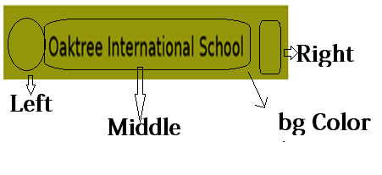

|  |
| --- |
| XML Code of top bar view : (Working) |
| <Screen Number="0" Type="" bgcolor="" bgImage="">  **<Top rows="" columns="" width="100" height="10" Type="0" Link="" bgcolor="#93950A" bgImage="">**  **<Element maxline="" Subtitle="" font="Rupee Foradian Standard,30,#000000" leftscalefactor="" rightscalefactor="" midscalefactor="" selectedBgcolor=" " bgcolor="#f38a25" txtColor="" Number="" Code="" Type="" Title="Oaktree International School" Bitmap="" OnClick="" width="100" leftper="15" rightper="15" middleper="70" height="100" left="back_icon" right="" middle="" leftClick="" rightClick="" body="" mailto="" subject="" distleft="" disttop="" rightbgColor="" leftbgColor="" midbgColor="" rightbgImage="" leftbgImage="" midbgImage="apply" />**  **</Top>**  <Middle rows="" columns="" width="100" height="90" Type="" Link=" bgcolor="#ffffff" bgImage="">  </Middle>  <Bottom rows="" columns="" width="" height="0" Type="" Link="" bgcolor="" bgImage="">  </Bottom>  </Screen> |

|  |  |
| --- | --- |
| Top bar XML Details : | |
| **Attributes** | **Work** |
| height | Height in % of the total height of that section |
| width | Width of total section. |
| Left | Image we want to see on the left side. |
| Right | Image we want to see on the right side. |
| bgcolor | Background color of the element |
| Title | Title name used for the bar . |
| Font | The font used for title |
| Onclick | The secrren number which we want to open |

**Picture view:**

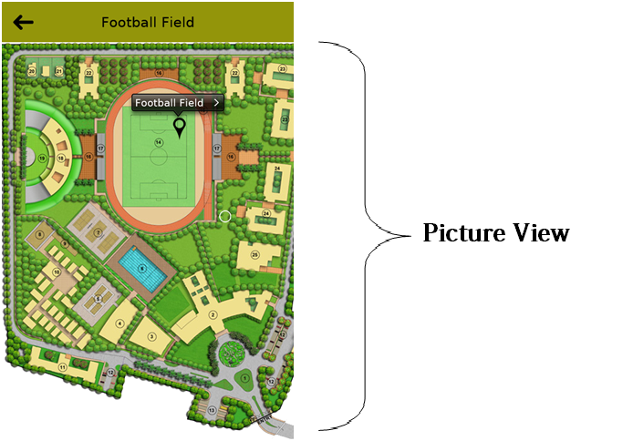

|  |
| --- |
| XML Code of Picture view : (Working) {NOT WORKING IN ANDROID} |
| <Screen Number="0" Type="" bgcolor="" bgImage="">  <Top rows="" columns="" width="100" height="10" Type="0" Link="" bgcolor="#93950A" bgImage="">  <Element maxline="" Subtitle="" font="Rupee Foradian Standard,30,#000000" leftscalefactor="" rightscalefactor="" midscalefactor="" selectedBgcolor=" " bgcolor="#f38a25" txtColor="" Number="" Code="" Type="" Title="Oaktree International School" Bitmap="" OnClick="" width="100" leftper="15" rightper="15" middleper="70" height="100" left="back_icon" right="" middle="" leftClick="" rightClick="" body="" mailto="" subject="" distleft="" disttop="" rightbgColor="" leftbgColor="" midbgColor="" rightbgImage="" leftbgImage="" midbgImage="apply" />  </Top>  **<Middle rows="" columns="" width="100" height="90" Type="8" Link=" bgcolor="#ffffff" bgImage="">**  **<Element maxline="" Subtitle="" font="" leftscalefactor="1.0" rightscalefactor=""** **midscalefactor="" selectedBgcolor="" bgcolor="" txtColor="" Number="" Code="" Type="" Title="" Bitmap="Home_more_direction_search_screen" OnClick=" " width="100" leftper="10" rightper="10" middleper="80" height="100" left="" right="" middle="" leftClick="" rightClick="" body="" mailto="" subject="" distleft="" disttop="" rightbgColor="" leftbgColor="" midbgColor="" rightbgImage="" leftbgImage="" midbgImage="" />**  **</Middle>**  <Bottom rows="" columns="" width="" height="0" Type="" Link="" bgcolor="" bgImage="">  </Bottom>  </Screen> |

|  |  |
| --- | --- |
| Picture View XML Details : | |
| **Attributes** | **Work** |
| height | Height in % of the total height of that section |
| width | Width of total section. |
| bgcolor | Background color of the element |
| Title | Title name used for the bar. |
| Font | The font used for title |
| Bitmap | The name of the image we want to display. |

**Text Field:**

This is a field where we can give header and content.

|  |
| --- |
| XML Code of Text Field : |
|  |

|  |  |
| --- | --- |
| Picture View XML Details : | |
| **Attributes** | **Work** |
| Title | This will give the title to our page means the header. |
| font | This will select the color, size and font for the title |
| Subtitle | we will write whatever we want to see as content in our page. |
| SubTitlefont | This will set the color, size and font type for the content text. |
| TitleGravity | This will set the alignment of our header means left/right/middle. |
| SubTitleGravity | This will set the alignment of the content. Means weather we want to start text from the middle, left or right |
| leftper | This will set the left margin of the content. |
| rightper | This will set the right margin of the content. |
|  |  |

NOTE: left and right margins of the header are fixed and 4% each.

In title and subtitles we can use HTML tags but the direct use is not possible because XML files doesn’t allow the use of <, > and ““”” means nesting of double cores so we will use escape characters.

**Button placement: (Type 43)**

This is a type by which we can place any button anywhere in the screen with the available dimensions.

|  |
| --- |
| XML Code of Text Field : |
|  |

|  |  |
| --- | --- |
| Button Placement XML Details : | |
| **Attributes** | **Work** |
| Title | This will give name to the buttom. |
| Xper | X- axis dimension |
| Yper | Y-axis dimension |
| Bitmap | Name of the image we want to use for button |
| Bgimage | Background image of section |
| Bgcolor | Background color of section |

The center of the button will lie upon the X-Y axis. When we apply bgimage or bgcolor we can use only one at a time.

**Agreement Screen: screen number = -2**

|  |
| --- |
| XML Code of a Agreement Screen : (Working) |
|  |

This screen can be the 1st screen only in the app. This screen is not necessary in any app.

In this screen we can use all the available types and we can enable and disable this screen.

**Save the original image of an HTML page Screen: screen number = 114**

|  |
| --- |
| XML Code of Save the original image of an HTML page Screen: (Working) |
|  |

This screen is for all the html pages which we are using in our app because with this we can save all the images available in the html pages of our app.

The middle part of this screen will always be of type 3 only because we are trying to open a link.

And there will be a button available for saving the image to the image gallery and on clicking upon this button it will open screen no 5.

**Save the image in the gallery: screen number = 5**

|  |
| --- |
| XML Code of Save the image in the gallery Screen: (Working) |
|  |

This screen is not a visible screen this is for internal use only this will hit the available url for saving the image.

.

**Picture Gallery:**

Picture gallery is a method of taking an image from the server at the run time. And after downloading the image we can see the image as many times we want without downloading again or without internet.

Picture gallery is a combination of type 12, 13 and 8 respectively.

Because these three types works in a particular sequence then only picture gallery becomes possible.

|  |
| --- |
| XML Code of Picture Gallery: (Working) |
|  |

**Type 12: Category View:**

This shows the different categories and for every category there is a category image. And it counts the no of images in each category and shows that with the category name in the bracket.

The category name can be of maximum 2 lines and if that exceeds then the remaining will be in the dotted form only.

And the grid will be of 2xN.

On clicking upon this in new screen it will use picture grid view means type 13.

**Type 13: Picture Grid View:**

This shows all the images in a grid of 3xN and downloads all the images in the thumbnail view not the complete image.

And on clicking upon the image it will open the image using the type 8 in new screen.

**Type 8: Picture detail view:**

This will first check that the image is available (locally means in Memory Card) or not if not then it will download that image from the given URL and if image is available the show that image directly.

**Flick Images (Type 20 and 20.1):**

This is a way by which images will change automatically the image can be banner image or some other image in app.

We have no need to write a bitmap for this element it will directly receive the images from the server and if app is in offline mode (After first time) it will take from storage device.

And we have to upload all the images which want to see in flick in advertisement section on server.

**Type 20:**

If we want the flick to be automatic.

**Type 20.1:**

If we want the flick to be manual.

**Type 20.2:**

If we want the flick to be automatic and with a fix set of images.

**Type 20.3:**

If we want the flick to be manually and with a fix set of images.

**Show Updates:**

**Type 10: News:**

This will show the news briefly.

**Type 11: Details:**

This will show the detailed news on clicking upon the corresponding News Brief..

**Type 24: Category:**

This will show different categories of news.

|  |
| --- |
| XML Code of Show Updates: (Working) type 10 |
| <Screen Number="722" Type="" bgcolor="" bgImage="">  <Top rows="" columns="" width="100" height="10" Type="0.1" Link="" bgcolor="#93950A" bgImage="">  </Top>  <Middle rows="" columns="" width="100" height="90" Type="10" Link="" bgcolor="#ffffff" bgImage="">  <Element maxline="" Subtitle="" font="Hero,30,#000000" SubTitlefont="Hero,30,#cacaca" ReadNewsfont="Hero,30,#cacaca" Datefont="Hero,40,#0000ff" Datebg="#abc000" Timefont="Hero,20,#ff00ff" SubTitleGravity="left" leftscalefactor="1.0" rightscalefactor="1.0" midscalefactor="1.0" selectedBgcolor="#f7a721" leftper="5" rightper="5" middleper="95" bgcolor="#f38a25" txtColor="" Number="1" Code="" Type="3" Title="" Bitmap="news_1" OnClick="Open_Screen 724" width="100" height="100" left="campus" right="" distleft="" disttop="" mailto="" body="" subject="" leftClick="" rightClick="" rightbgColor="" leftbgColor="" midbgColor="" rightbgImage="" leftbgImage="" midbgImage="" />  </Middle>  <Bottom rows="1" columns="3" width="100" height="0" Type="" Link="" bgcolor="" bgImage="">  </Bottom>  </Screen> |

|  |
| --- |
| XML Code Type 11 : (Working) |
| <Screen Number="724" Type="" bgcolor="" bgImage="">  <Top rows="" columns="" width="100" height="10" Type="0" Link="" bgcolor="#93950A" bgImage=""> </Top>  <Middle rows="" columns="" width="100" height="90" Type="11" Link="" bgcolor="#ffffff" bgImage="">  <Element maxline="" Subtitle="" font="Hero,37,#000000" SubTitlefont="Hero,30,#cacaca" Datefont="Hero,20,#0000ff" Timefont="Hero,20,#ff00ff" SubTitleGravity="left" leftscalefactor="1.0" rightscalefactor="1.0" midscalefactor="1.0" selectedBgcolor="#f7a721" leftper="5" rightper="5" middleper="95" bgcolor="#f38a25" txtColor="" Number="1" Code="P001" Type="3" Title="Faculty" Bitmap="news_2" OnClick="" width="100" height="100" left="campus" right="" distleft="" disttop="" mailto="" body="" subject="" leftClick="" rightClick="" rightbgColor="" leftbgColor="" midbgColor="" rightbgImage="" leftbgImage="" midbgImage="" />  </Middle>  <Bottom rows="1" columns="3" width="100" height="0" Type="" Link="" bgcolor="" bgImage="">  </Bottom>  </Screen> |

|  |
| --- |
| XML Code Type 24: (Working) |
| <Screen Number="723" Type="" bgcolor="" bgImage="">  <Top rows="" columns="" width="100" height="10" Type="0" Link="" bgcolor="#93950A" bgImage="">  </Top>  <Middle rows="" columns="" width="100" height="90" Type="24" Link="" bgcolor="#ffffff" bgImage="">  <Element maxline="" Subtitle="" font="Hero,37,#000000" leftscalefactor="1.0" rightscalefactor="1.0" midscalefactor="1.0" selectedBgcolor="#f7a721" leftper="5" rightper="5" middleper="95" bgcolor="#f38a25" txtColor="" Number="1" Code="" Type="" Title="" Bitmap="" OnClick="Open_Screen 722" width="100" height="100" left="campus" right="" distleft="" disttop="" mailto="" body="" subject="" leftClick="" rightClick="" rightbgColor="" leftbgColor="" midbgColor="" rightbgImage="" leftbgImage="" midbgImage="" />  </Middle>  <Bottom rows="1" columns="3" width="100" height="10" Type="" Link="" bgcolor="" bgImage="">  </Bottom>  </Screen> |